Indholdsfortegnelse
Der blev ikke fundet nogen elementer til indholdsfortegnelsen.

Aflevering 1
The purpose of the exercise is to gain an insight w.r.t. the application of Hertz dipole approximation for wire antennas.
You are expected to make a simulation model that is capable of calculating and displaying the radiation pattern (magnitude of the E -field) for the meander line design proposed in the paper "Empirical Relation for Designing the Meander Line Antenna" at 1060 MHz. Furthermore, the model should be able to calculate the 3dB E- and H- plane angles and directivity of the antenna. Validate your results by checking against the results obtained by using the corresponding formulas in the paper.
It is recommended to use "Hertz dipole resolution" as a parameter. Then, you will be able to adjust to find the proper resolution needed to produce valid results. This is also beneficial for debugging because coarse resolution makes the simulation faster ;)
Please note that hand-in of the exercise source files and results is part of the mandatory course work to qualify for participation in the oral exam.

$f≔1,060GHz$
${\left[∆ϕ, ∆θ\right]}_{E,H|{\left|T\right|}_{max}-3dB}$
$Directivity{\left.​\right|}_{{\left|T\right|}_{max}-3dB}$.
"Hertz dipole resolution”
“The meander line structure is design on glass epoxy (FR4)”
“where A.g is the guide wavelength in the glass epoxy substrate at the centrefrequency of 1060MHZ”
Glass epoxy (FR4) - Core / substrate?
“The current directions are changing in every half wavelength and there are more than four half wavelength changes in this design”

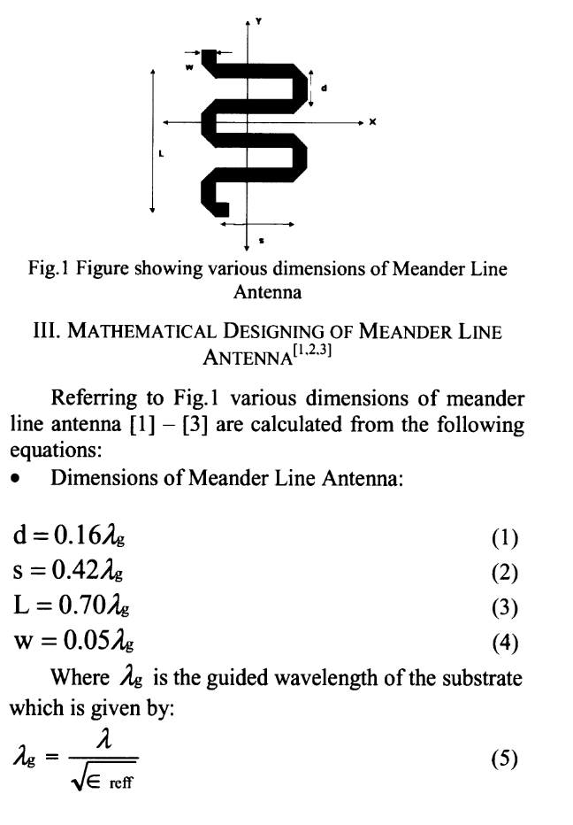

Given that I’ve not gotten any finite radius to visualize for, I’ll set the radius of observation myself.
I’ll simulate for $0≤r≤30m$.

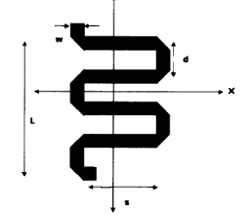

“The current directions are changing in every half wavelength and there are more than four half wavelength changes in this design”
“More than four half…” Deler det op I 4 sektioner.
$I+-+·=sektion=d+s+ukendt=0,5λ_{g}$
$I+-+·=λ_{g}·\left(0,16+0,42+ukendt\right)=0,5λ_{g}$
$I+-+·=λ_{g}·\left(0,58+ukendt\right)=0,5λ_{g}$
Så allerede med de kendte led så ændrer bølgen sig med 2 bølgelængder for 4 sektioner. Lad mig prøve at designe for 3 bølgelængders skift, præcist.
$4·sektioner+I+·=3λ_{g}$
$4·sektioner+I+·=λ_{g}·\left(4·\left(0,58+ukendt\right)+d+ukendt\right)=3λ_{g}$
$λ_{g}·\left(2,48+5·ukendt\right)=3λ_{g}$
$λ_{g}·\left(2,48+5·0,104\right)=3λ_{g}$

